**TELANGANA GRAMEENA BANK**

**ASSET & LIABILITY MANAGEMENT TOOL**

**STANDARD OPERATING PROCEDURE**

1. **Objective:**

To assess and generate Bank’s Inflows and Outflows as per the guidelines / format of NABARD Return - Appendix-I - Statement of Structural Liquidity.

1. **Inputs Required**
2. Daily Unsplit Reports by C-Edge:
   1. Trail Balance (TRIAL_BALANCE_REPORT.prt)
   2. CCOD / Loan Balance Files (depd0580.prt & lond2390.prt)
   3. Residual Maturities of Deposits (trmm0403.prt)
3. Investment Particulars (Entry-wise):
   1. Bonds
   2. SLR
   3. Mutual Funds
   4. TDRs
4. Mandatory Balances to be maintained with Other Banks as Current Accounts
5. Refinances(Entry-wise)
6. **Schema:**

Databases required: investments, refinance.

Tables (structure only) – Refer file - investments_structure.sql and refinance_structure.sql.

1. **Pre-Requisites:**
2. Ensure all CGLs of Trial Balance are mapped either with cgl_AR1_mapping table or cgl_AR2_mapping table.
3. All CGLs are to be mapped as per Crystal Mapping.
4. Ensure all Investment Particulars are up-to-date.
5. Ensure all Refinances Particulars are up-to-date.
6. Ensure Current Account details are up-to-date.
7. **Modules:**
8. Data Loading:
   1. ALM -> Load Data – Admin page
   2. Preprocess the daily reports as per the Schema mentioned below:

|  |  |  |
| --- | --- | --- |
| Report Name | Load into Table | Remarks |
| TRIAL_BALANCE_REPORT.prt | dailyweekly | RUN_DATE - AsonDate |
| depd0580.prt & lond2390.prt | npa | RUN_DATE - AsonDate |
| trmm0403.prt | Direct upload and value extraction |  |

* 1. Select trmm0403.prt file and click **Load Data**
  2. Wait for response and then click **Bulk Update**
  3. Data loaded successfully.

1. Record Maintenance – Investments, Current A/Cs & Refinances
   1. Bond – Add / Edit / Delete
   2. SLR – Add / Edit / Delete
   3. Mutual Funds – Add / Edit / Delete
   4. TDRs – Add / Edit / Delete
   5. Refinances– Add / Edit / Delete
2. Trend Analysis:
   1. View Bank’s Assets & Liabilities statement as on any date.
   2. Trend of Parameter-wise Time Band-wise
3. **Code Changes to be done:**
   1. Change the file includes path information.
   2. Check DB connection code in all pages.
   3. Change all DB connections with different IPs to localhost.
4. **Screen Shots:**
   1. Data Loading:

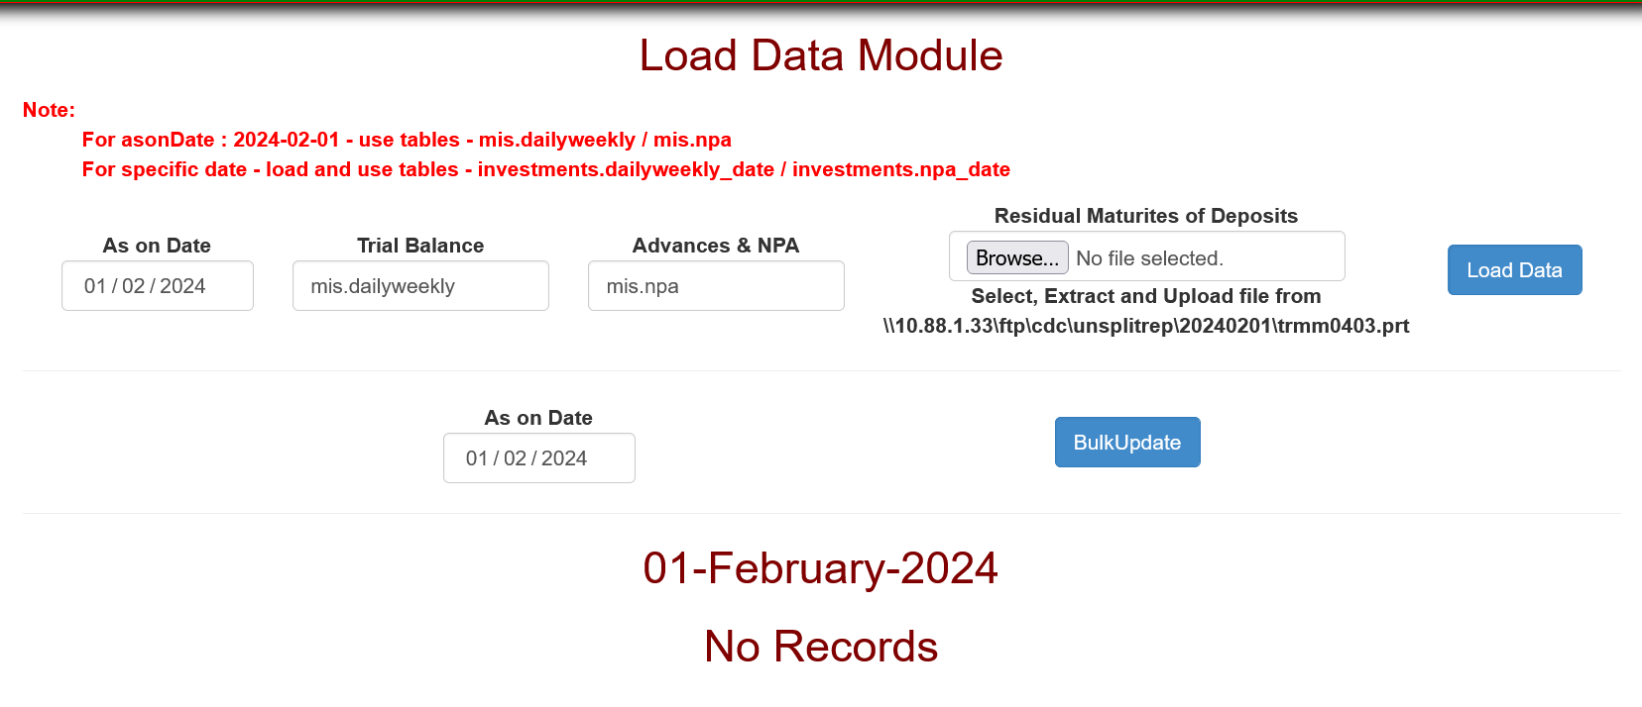

* 1. Bonds

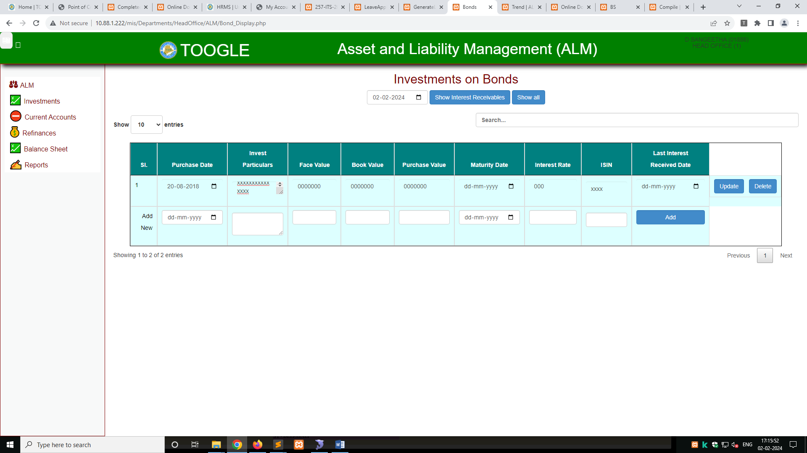

* 1. SLR:

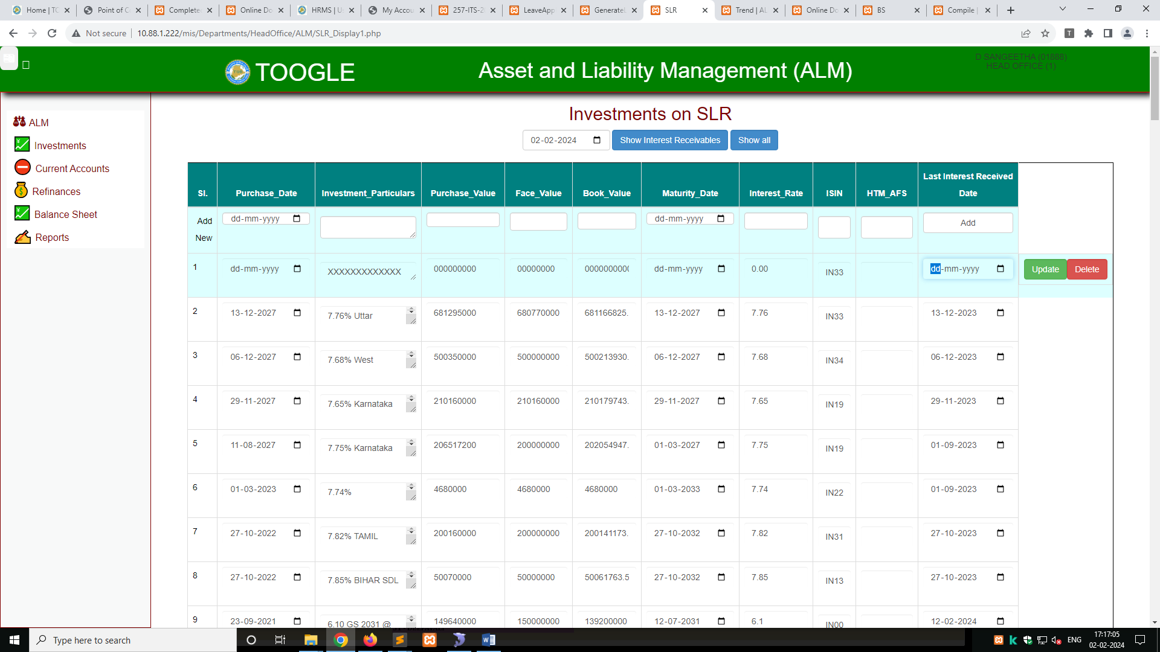

* 1. Deposits in Other Banks – TDRs

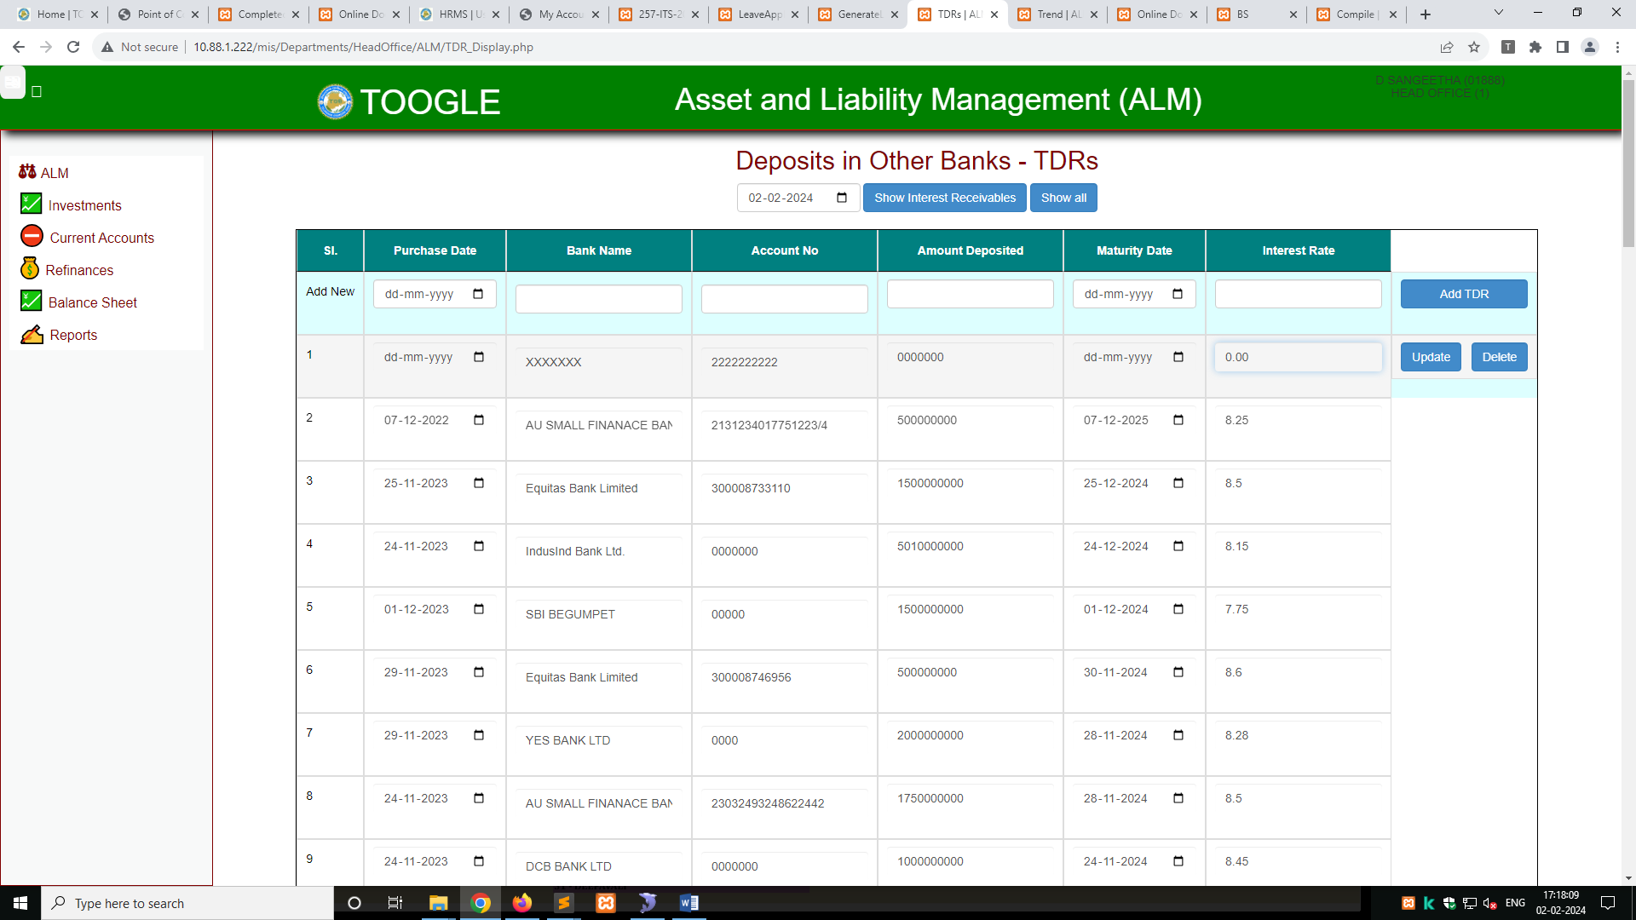

* 1. Current Accounts

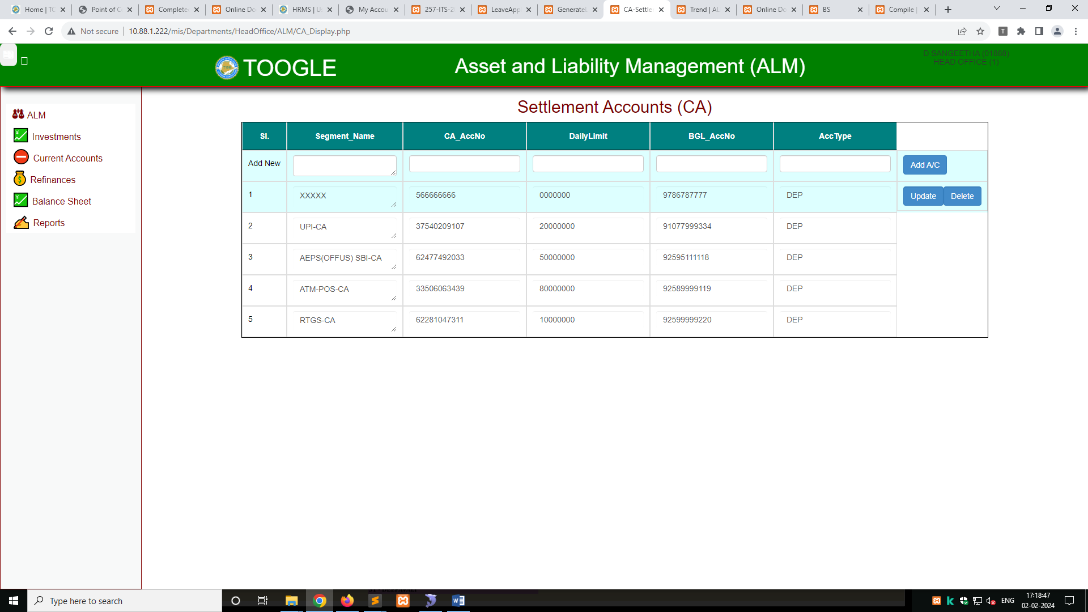

* 1. Refinances – Outstanding

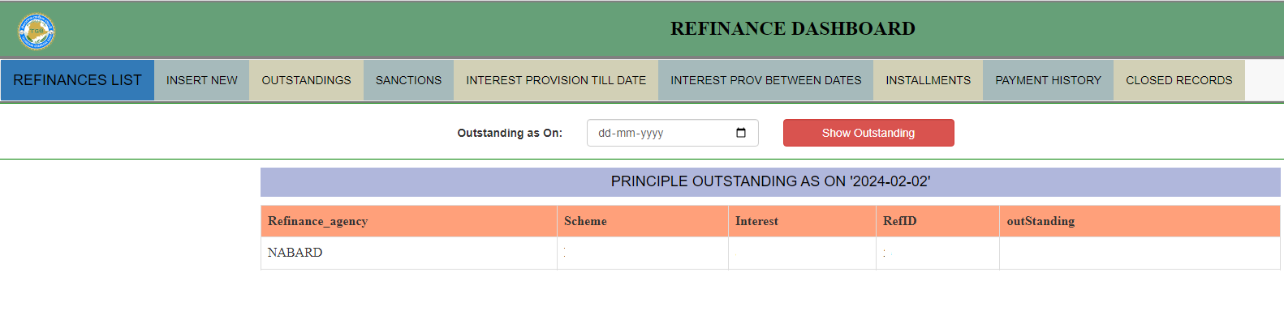

* 1. Refinances – Interest Provisions

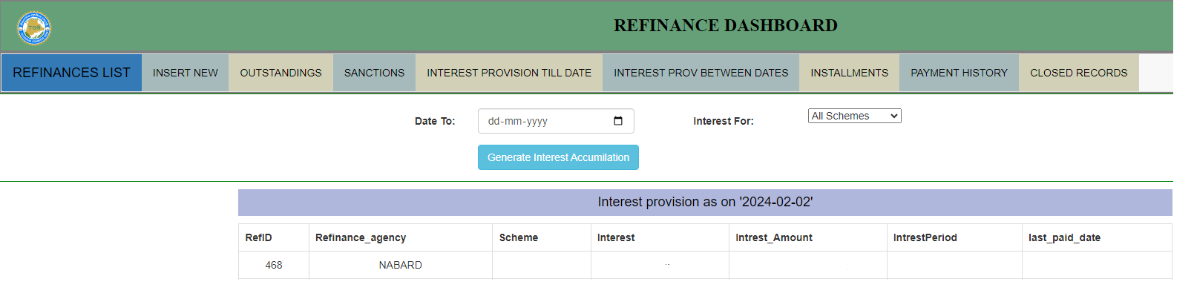

**Contact:**

**D. Sangeetha, Senior Manager (IT) – 9491041965**

**M Praveen Kumar, Manager (IT) – 7901617565**

**Gunda Naresh, Senior Manager (INVESTMENT) – 7901617540**

****